Reebok Answer III Shoes
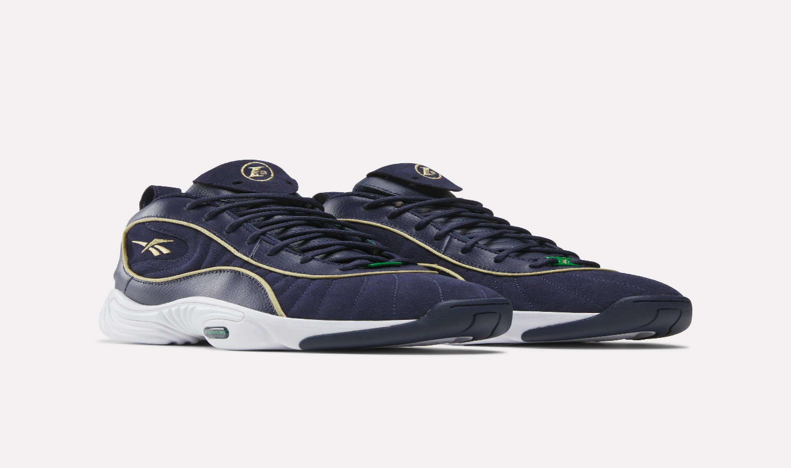
PRICE: Approximately Rs. 16,999

_{Introduction:}
The Reebok Answer III Shoes are a legendary basketball sneaker designed to deliver both performance and style. Originally popularized on the court, these shoes combine superior cushioning, stable support, and a bold design that stands out in both sports and casual wear. With a focus on comfort and durability, the Answer III ensures your feet are supported during high-intensity games or daily wear. The unique blend of materials and innovative Reebok technology makes these sneakers not just functional but a statement piece for sneaker enthusiasts. These shoes bring a mix of performance and heritage to your collection.
Product Overview:
The Reebok Answer III Shoes feature a combination of high-quality leather and synthetic materials, offering excellent ankle support and cushioning. Designed for basketball, they provide traction, comfort, and durability, making them suitable for both indoor and outdoor courts.
About the Brand:
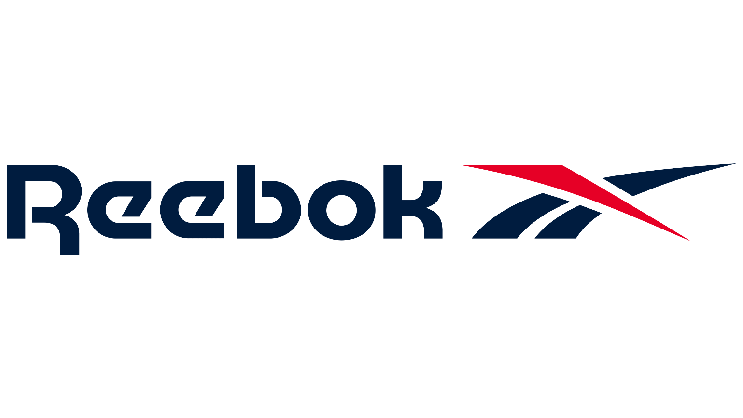
Reebok is a globally recognized sports and fitness brand known for producing reliable, high-performance athletic gear and accessories. With decades of experience in sports innovation, Reebok products are trusted by athletes and everyday users alike for quality, durability, and practical design.

Key Features:
- Iconic design inspired by Allen Iverson’s signature style
- Responsive cushioning for high-impact movements
- Durable leather and synthetic upper for support and longevity
- Excellent traction on indoor and outdoor courts
- Lightweight yet sturdy construction for quick movements

Design & Build Quality:
The Reebok Answer III Shoes feature a low-top silhouette with reinforced overlays for extra stability. Attention to detail in stitching and material placement ensures both durability and a stylish appearance.
Storage & Capacity:
The shoes are designed to fit standard foot sizes comfortably, with a secure lace-up closure to ensure a snug fit. Easy to store in gym bags or lockers, they are ideal for daily wear or intense basketball activities.
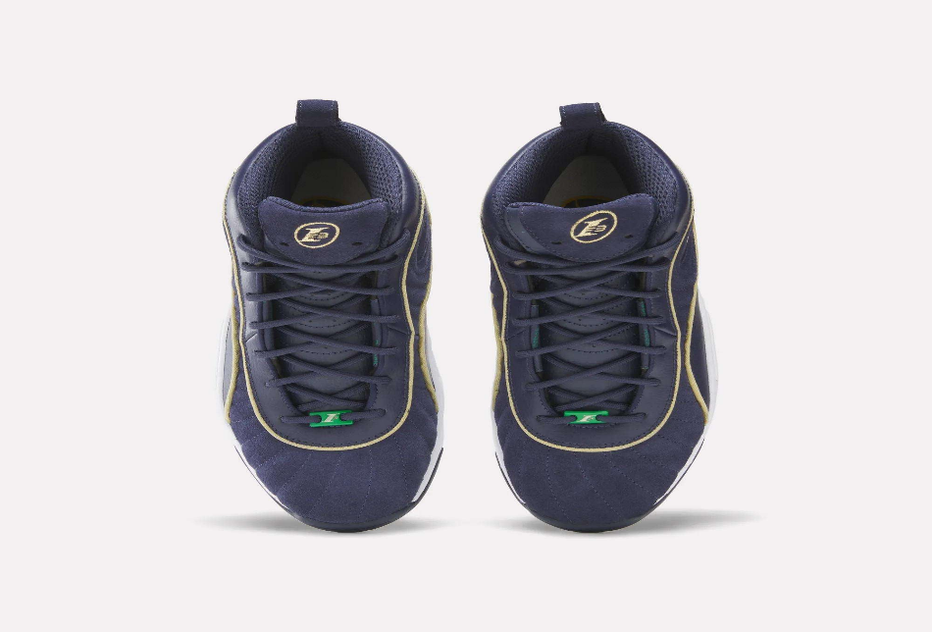

Material & Durability:
Made from premium leather and synthetic materials, the Reebok Answer III Shoes provide strength, flexibility, and long-lasting performance. The padded collar and tongue enhance comfort, while the sturdy rubber sole ensures durability even under rigorous use.
Ideal For:
- Basketball players and sports enthusiasts
- Sneaker collectors and casual wearers
- Daily wear or high-intensity training sessions
- Standard shoe sizes with lace-up closure for a secure fit
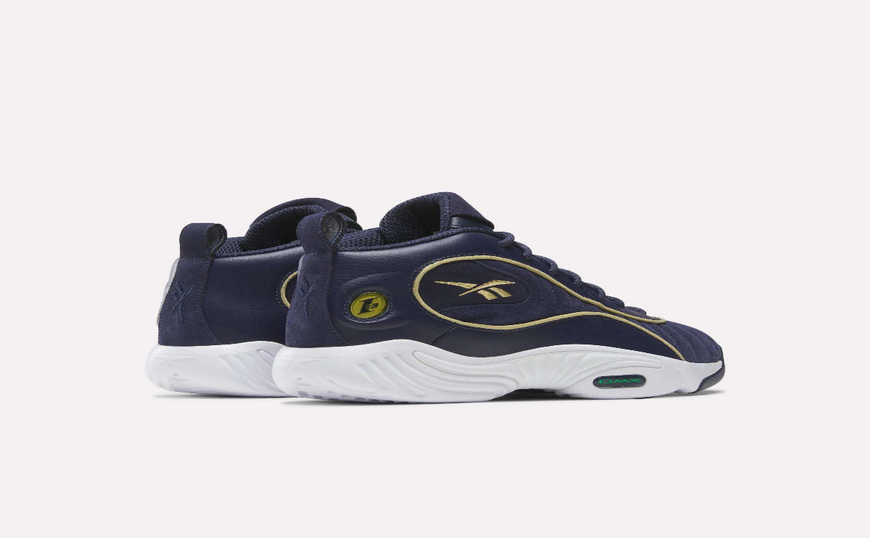

Care Instructions:
- Wipe with a damp cloth or soft brush
- Avoid direct exposure to heat or sunlight
- Store in a cool, dry place to maintain shape and quality
Product Specifications:
- Brand: Reebok
- Model: Answer III
- Type: Basketball Shoes / Sneakers
- Upper Material: Leather + Synthetic
- Outsole: Rubber
- Closure: Lace-up
- Colors Available: Multiple colorways
- Sizes: US 6–12 (approx.)
Product Summary:
The Reebok Answer III Shoes combine legendary style, comfort, and performance in a single sneaker. Perfect for both the court and casual wear, they offer long-lasting durability and iconic design for athletes and sneaker fans alike.

